**Release Note –** **Resource Explorer**

Quarterly Product Release

Version 24.1.0.0



C

ONTACTS

info@uppwise.com

[LinkedIn Company Profi](https://www.linkedin.com/company/uppwise)le

[www.uppwise.c](http://www.uppwise.com/)om

Quarterly Product Release Version 23.3.0.1



C

ONTACTS

info@uppwise.com

[LinkedIn Company Profi](https://www.linkedin.com/company/uppwise)le

[www.uppwise.c](http://www.uppwise.com/)om

This serves as a Feature Release Note to apprise our customers of the latest addition to the application, released with the Uppwise 2024 **Quarter 1 release 24.1.0.0**

# Feature: Resource Explorer

We're excited to introduce a new module which is Resource Explorer, it’s a comprehensive tool designed to facilitate efficient management and exploration of resources within a system or platform. It serves as a centralized hub for users to navigate, analyse, and take actions related to various resources.

**User Permissions:**

* Access to the Resource Explorer is based on user permissions (Read/Write) configured in role settings.
* Admin users have full access to the RE workspace, with the menu visible by default.
* Department Managers require RE permission for access, restricted to department and child department resources.
* General Users with RE permission can access resources within their COS node and child COS nodes.

**Menu Access:**

Users access the Resource Explorer module via the navigation bar using the "Explorer" or "RE" menu icon.

**Workspace Layout Management:**

* Fixed layouts allow easy organization and visibility management via the Layout Creation popup.
* Each layout accommodates a single widget, ensuring simplicity and focus.

**Project Assignment View:**

* Displays project data hierarchically upon entry.
* Effort calculation (Baseline, Actual, Forecast) enhances project analysis.
* Filtering options (Project, Resource, State, etc.) refine views.
* Resource visibility follows user permissions and hierarchical structure.

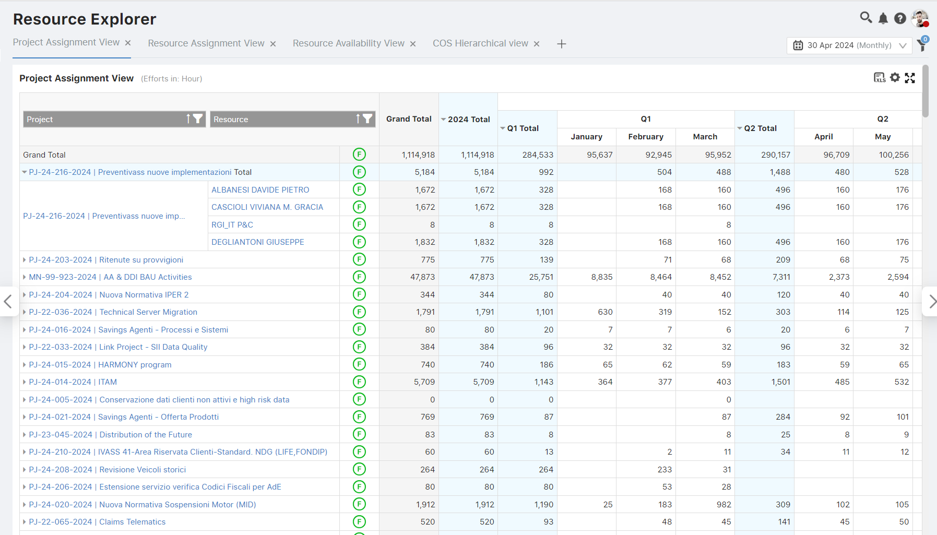

**Resource Assignment View:**

* Displays resource data with allocated projects.
* Efforts represented in Baseline, Actual, and Forecast terms.
* Resource details alongside project allocation within the same widget.
* Read-only visualization for associated project resources.

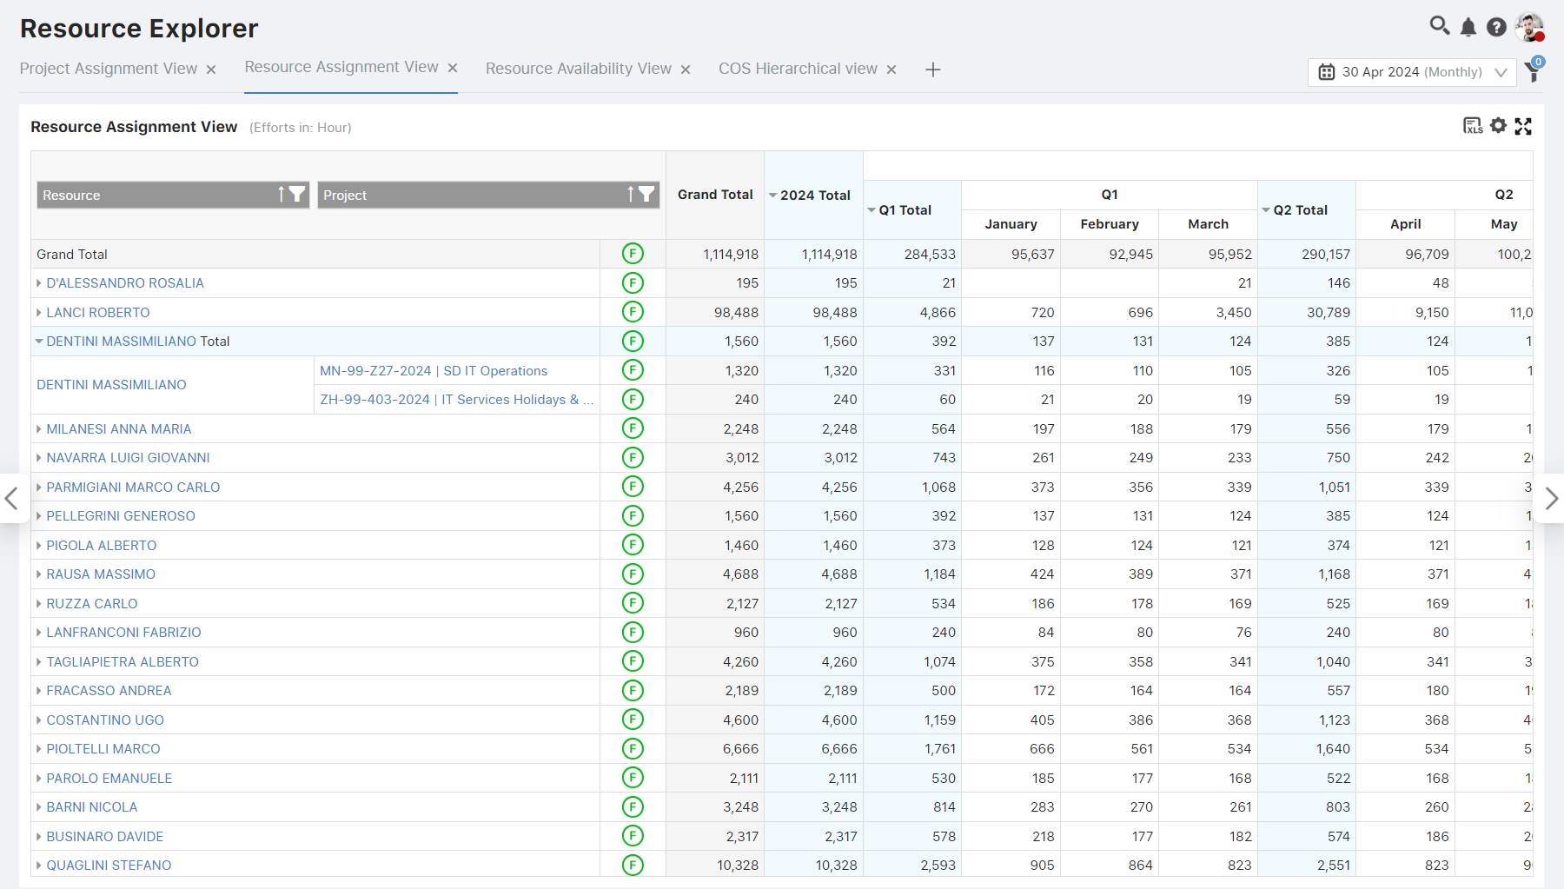

**Period Settings:**

* Users can set periods (e.g., Year to date, specific period).
* Option to limit visible years for performance optimization.

**Project Team Building Widget (PTB):**

* Positioned below Project and Resource Assignment Views.
* Dynamic updates based on selected projects for resource-based data.
* Customizable settings for personalized configurations.
* Empowers users with comprehensive project team management functionalities.

**Edit Resource View Widget (ERV):**

* Displays allocated projects upon resource selection.
* Dynamically updates based on selected resources.
* Custom settings for personalized configurations.

**Availability View:**

* Visualizes resource data/Chart based on selected groupings.
* Resource names alongside availability categorized by Forecast, Availability, and Net Availability.
* Color-coded rows for easy interpretation.
* Clicking on a resource load detailed ERV view for further analysis.

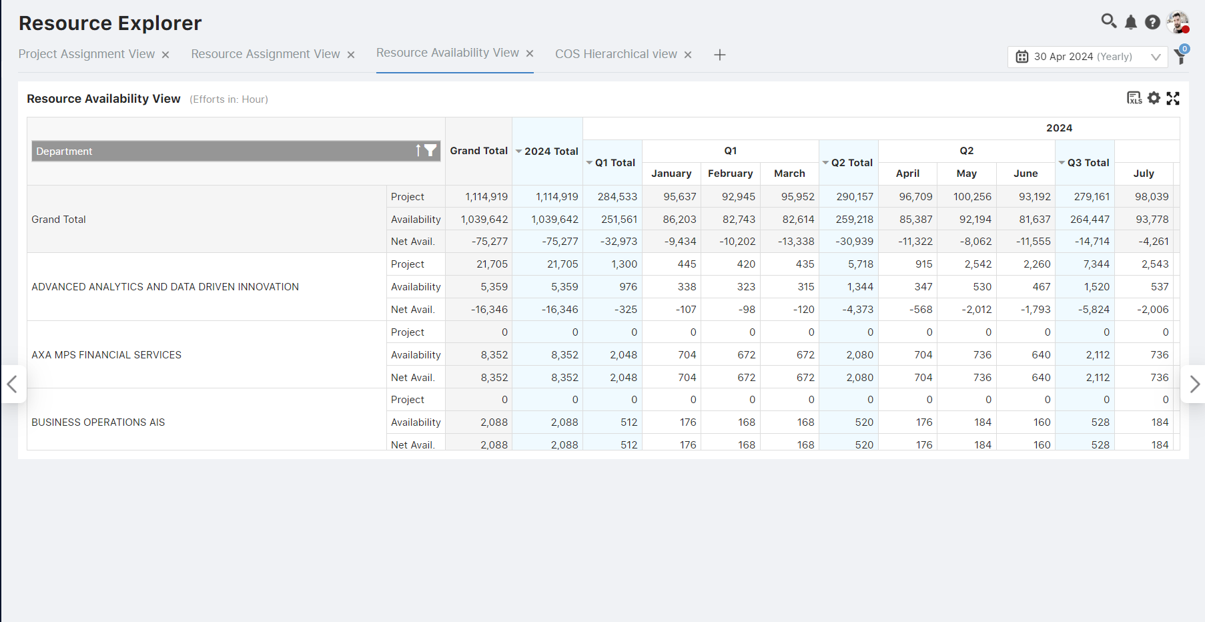

**COS Hierarchical View:**

* Hierarchical view based on COS for resource-COS association.
* Expanding COS nodes reveals associated resources.
* Resource-COS association available in resource edit page for streamlined management.

